**2. JUnit_Advanced Testing exercices**

**Exercise 1: Parameterized Tests**

**CODE**

***File name: EvenChecker.java***

package com.example;

public class EvenChecker {

public boolean isEven(int number) {

return number % 2 == 0;

}

}

***File name: EvenCheckerTest.java***

package com.example;

import org.junit.jupiter.params.ParameterizedTest;

import org.junit.jupiter.params.provider.ValueSource;

import static org.junit.jupiter.api.Assertions.*;

public class EvenCheckerTest {

EvenChecker checker = new EvenChecker();

@ParameterizedTest

@ValueSource(ints = {2, 4, 6, 8, 10, -2, 0})

public void testIsEvenTrue(int input) {

assertTrue(checker.isEven(input));

}

@ParameterizedTest

@ValueSource(ints = {1, 3, 5, 7, -1, -3})

public void testIsEvenFalse(int input) {

assertFalse(checker.isEven(input));

}

}

**OUTPUT**

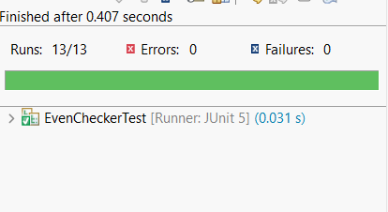

**Exercise 2: Test Suites and Categories**

**CODE**

***File name: Calculator.java***

package com.example;

public class Calculator {

public int add(int a, int b) {

return a + b;

}

public int subtract(int a, int b) {

return a - b;

}

}

***File name: AdditionTest.java***

package com.example;

import org.junit.jupiter.api.Test;

import static org.junit.jupiter.api.Assertions.*;

public class AdditionTest {

Calculator calc = new Calculator();

@Test

public void testAdd() {

assertEquals(7, calc.add(3, 4));

}

}

***File name: Subtraction.java***

package com.example;

import org.junit.jupiter.api.Test;

import static org.junit.jupiter.api.Assertions.*;

public class SubtractionTest {

Calculator calc = new Calculator();

@Test

public void testSubtract() {

assertEquals(5, calc.subtract(10, 5));

}

}

***File name: AllTests.java***

package com.example;

import org.junit.platform.suite.api.SelectClasses;

import org.junit.platform.suite.api.Suite;

@Suite

@SelectClasses({

AdditionTest.class,

SubtractionTest.class

})

public class AllTests {

// No code needed – annotations handle everything

}

**OUTPUT**

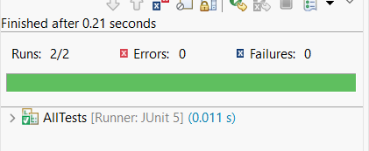

**Exercise 3: Test Execution Order**

**CODE**

***File name: OrderedTests.java***

package com.example;

import org.junit.jupiter.api.MethodOrderer.OrderAnnotation;

import org.junit.jupiter.api.Order;

import org.junit.jupiter.api.Test;

import org.junit.jupiter.api.TestMethodOrder;

import static org.junit.jupiter.api.Assertions.*;

@TestMethodOrder(OrderAnnotation.class) // ✅ Enables ordered execution

public class OrderedTests {

@Test

@Order(3)

public void testC() {

System.*out*.println("Running testC()");

*assertTrue*(true);

}

@Test

@Order(1)

public void testA() {

System.*out*.println("Running testA()");

*assertEquals*(4, 2 + 2);

}

@Test

@Order(2)

public void testB() {

System.*out*.println("Running testB()");

*assertNotNull*("JUnit");

}

}

**OUTPUT**

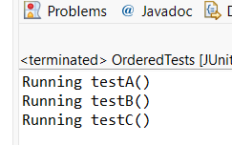

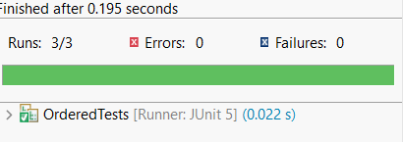

**Exercise 4: Exception Testing**

**CODE**

***File name: ExceptionThrower.java***

package com.example;

public class ExceptionThrower {

public void throwException(String input) {

if (input == null || input.isEmpty()) {

throw new IllegalArgumentException("Input cannot be null or empty");

}

// Otherwise, do something

System.*out*.println("Valid input: " + input);

}

}

***File name: ExceptionThrowerTest.java***

package com.example;

import org.junit.jupiter.api.Test;

import static org.junit.jupiter.api.Assertions.*;

public class ExceptionThrowerTest {

ExceptionThrower thrower = new ExceptionThrower();

@Test

public void testThrowExceptionWithNull() {

// Assert that exception is thrown when input is null

*assertThrows*(IllegalArgumentException.class, () -> {

thrower.throwException(null);

});

}

@Test

public void testThrowExceptionWithEmptyString() {

// Assert that exception is thrown when input is empty

*assertThrows*(IllegalArgumentException.class, () -> {

thrower.throwException("");

});

}

@Test

public void testValidInputDoesNotThrow() {

// Assert that no exception is thrown with valid input

*assertDoesNotThrow*(() -> {

thrower.throwException("Hello");

});

}

}

**OUTPUT**

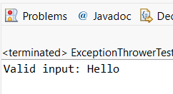

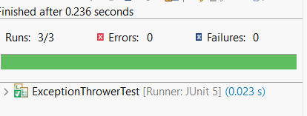

**Exercise 5: Timeout and Performance Testing**

**CODE**

***File name: PerformanceTester.java***

package com.example;

public class PerformanceTester {

public void performTask() {

// Simulate a task that takes time

try {

Thread.*sleep*(100); // 100 milliseconds

} catch (InterruptedException e) {

Thread.*currentThread*().interrupt();

}

}

}

***File name: PerformanceTesterTest.java***

package com.example;

import org.junit.jupiter.api.Test;

import static org.junit.jupiter.api.Assertions.*;

import java.time.Duration;

public class PerformanceTesterTest {

PerformanceTester tester = new PerformanceTester();

@Test

public void testPerformTaskCompletesInTime() {

// Task should complete within 500 milliseconds

*assertTimeout*(Duration.*ofMillis*(500), () -> {

tester.performTask();

});

}

@Test

public void testPerformTaskFailsIfTooSlow() {

// Example: this would fail if task took more than 50ms

*assertTimeout*(Duration.*ofMillis*(50), () -> {

tester.performTask();

});

}

}

**OUTPUT**

